* Microservice architecture is collection of standalone micro application. Each micro application looks like standalone application.

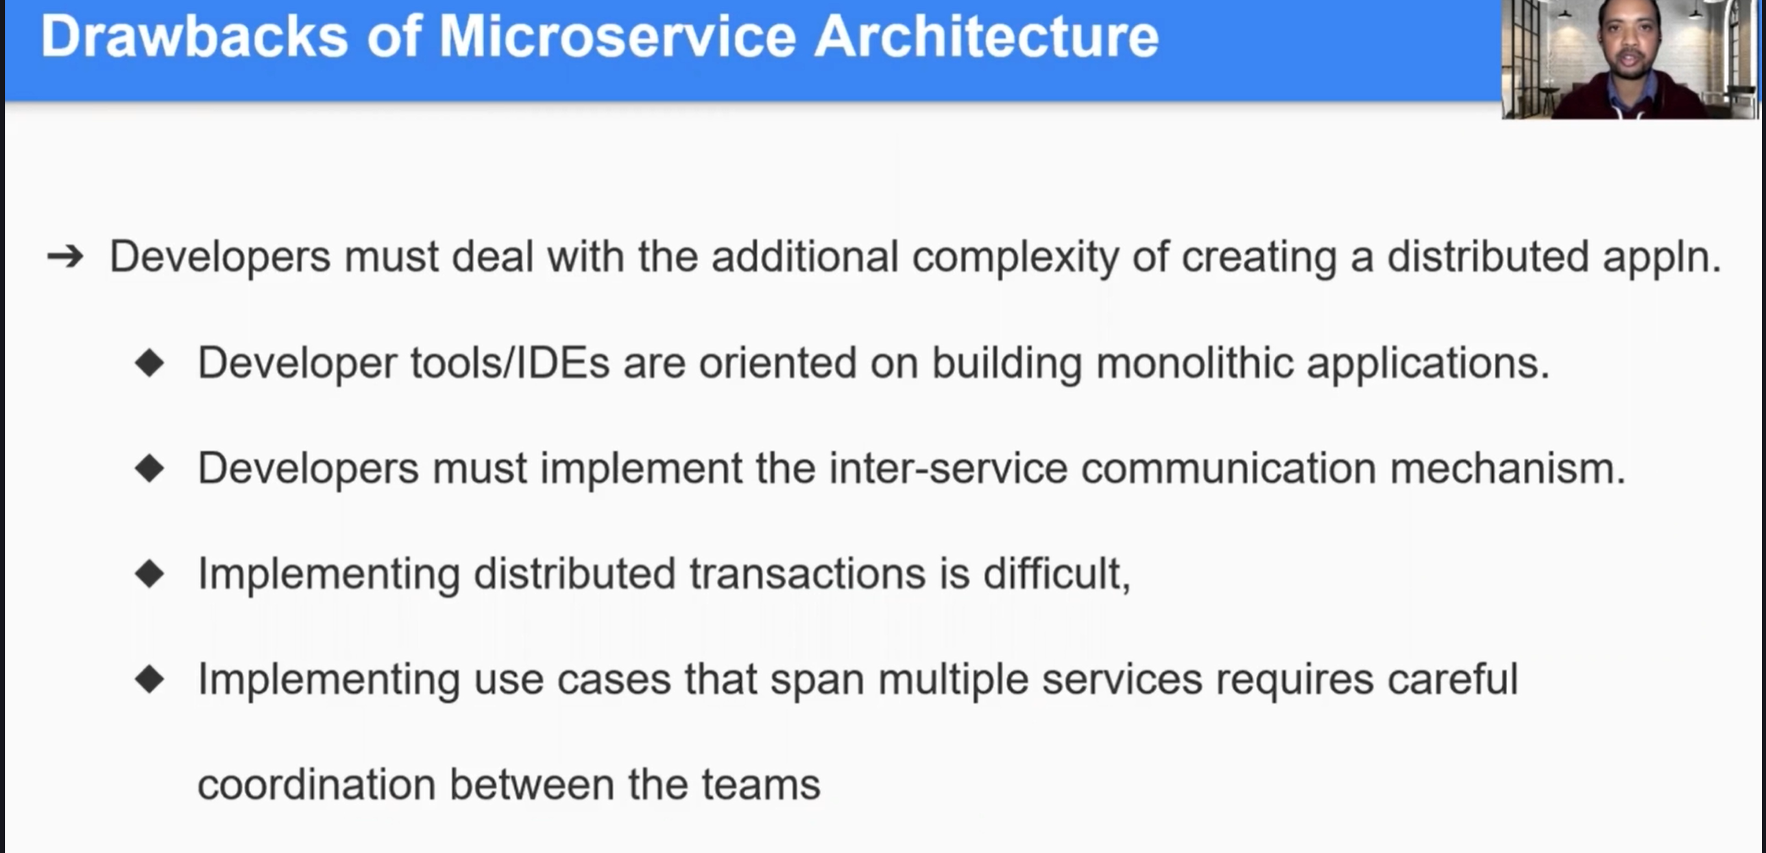

* Each microservice may have their own micro database and that database have their own transactions. So, in microservice architecture there are more database transactions. Manging databases and their rollbacks are challenging.

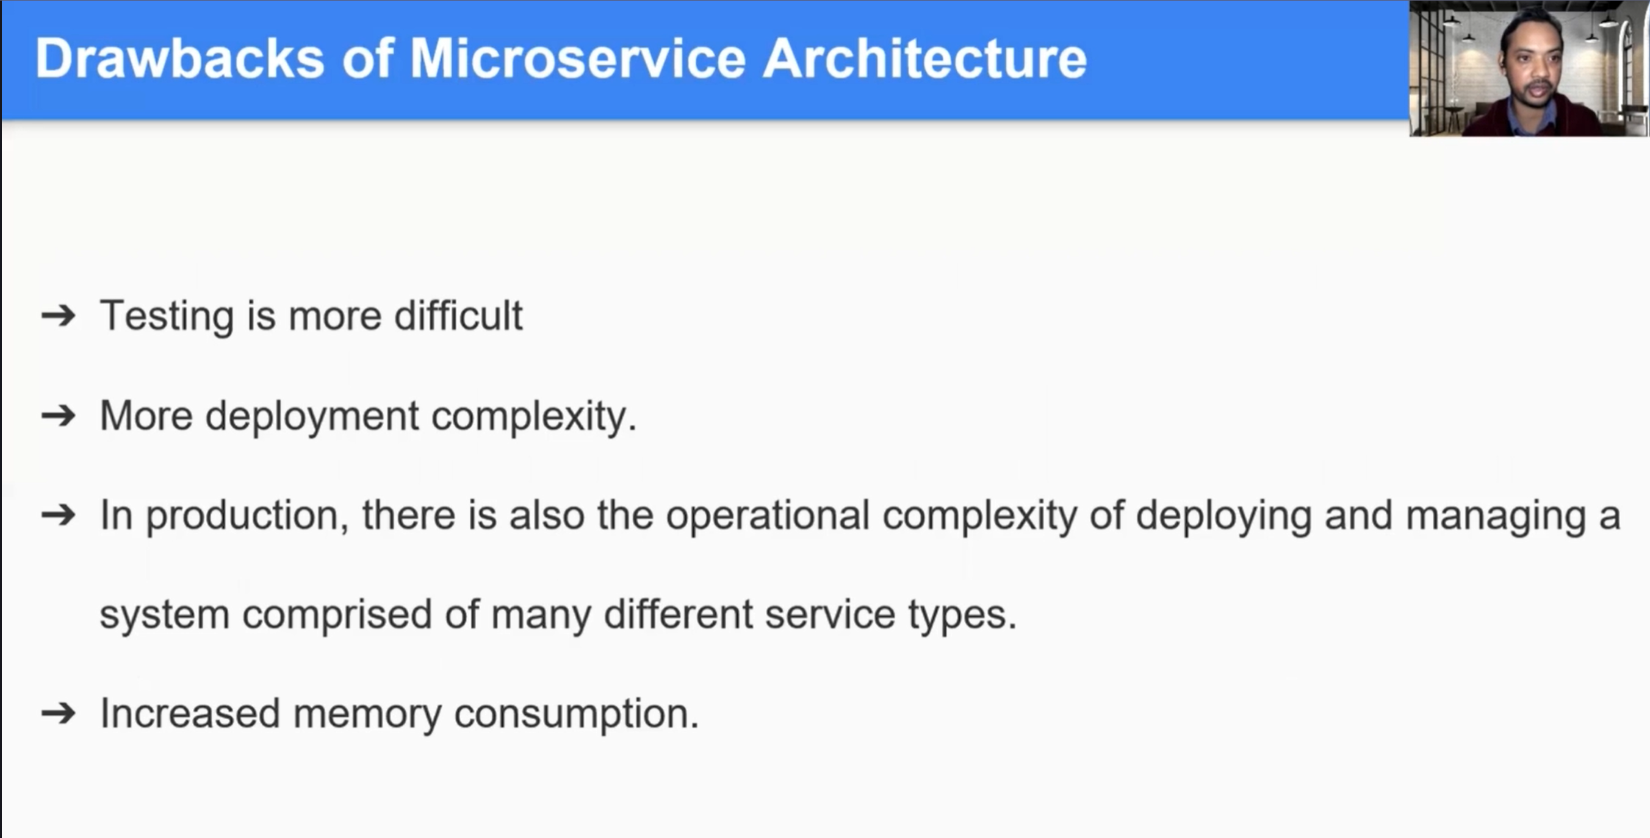

* Might need to use more resources.